1. With the Correlation being .84 between Tumor volume and weight, one could say tumor volume is a strong predictor of tumor weight.
2. There was only one outlier present among the 4 most effective treatments in infubinol.
3. 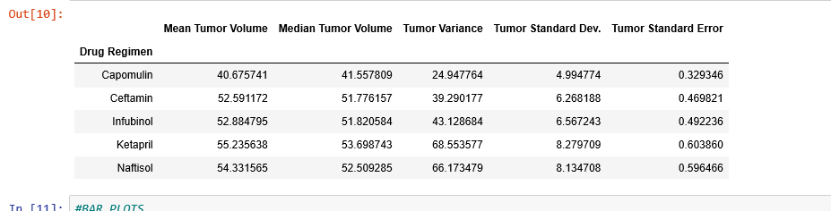

Interesting to see a large tumor variance between different drug treatments, meaning some drugs had more consistent results (cappomulin) vs other drug treatments (Naftisol).